**Lab File**

**Name: T.Aswin Barath**

**USN:18BTRSE031**

**Subject: Database Management Systems Lab**

**Subject Code: 18CS4SP04L**

**Question 5**: Create the table for

(a) COMPANY database

(b) STUDENT database

and Insert five records for each attributes.

**Aim:** To create a table for company database and student database and insert 5 rows in each attributes.

**(a) COMPANY database**

**SQL Queries :-**

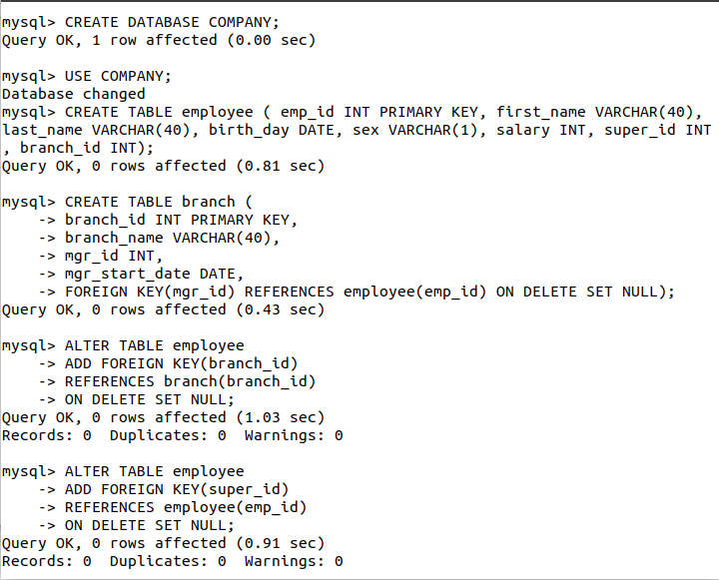

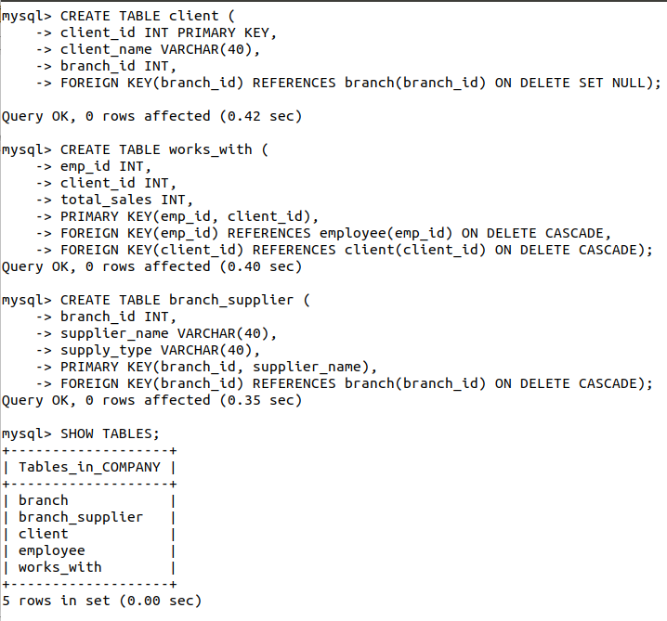

**Company Database Schema**

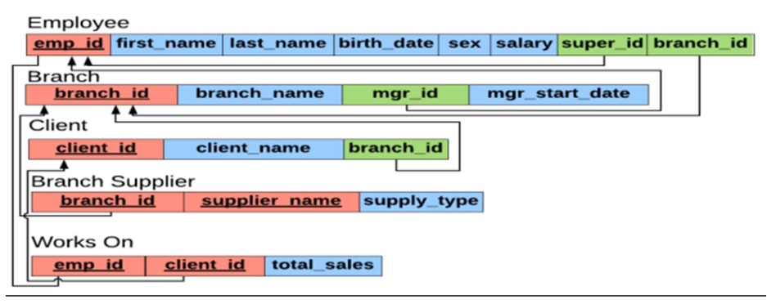

**Company ER Diagram**

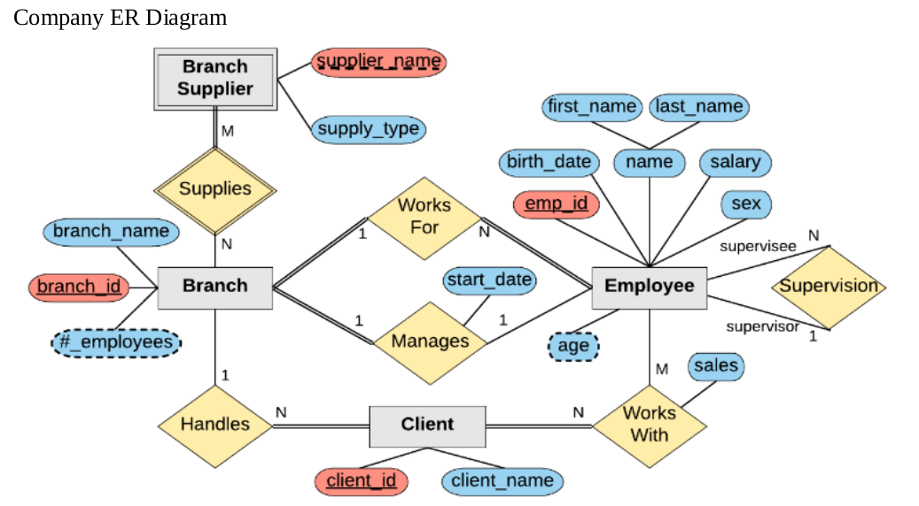

Insertion of rows to the tables employee, branch,branh_supplier, clients and works_with respectively:

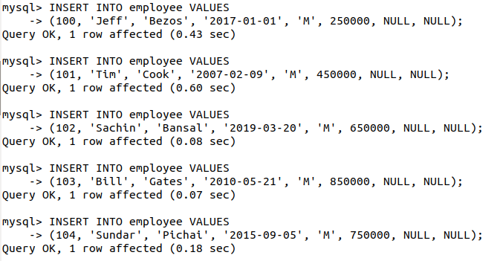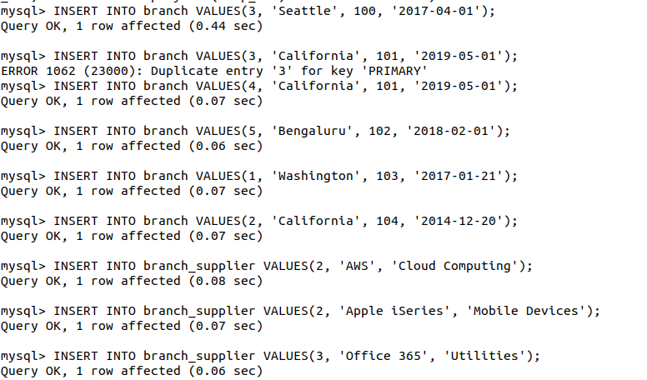

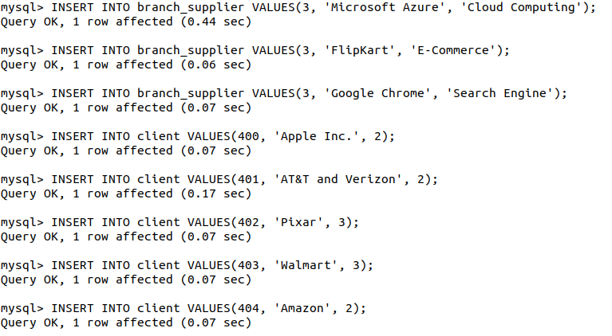

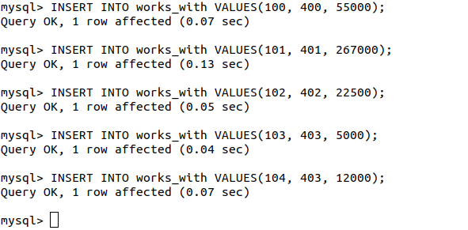

**Display of All Tables :-**

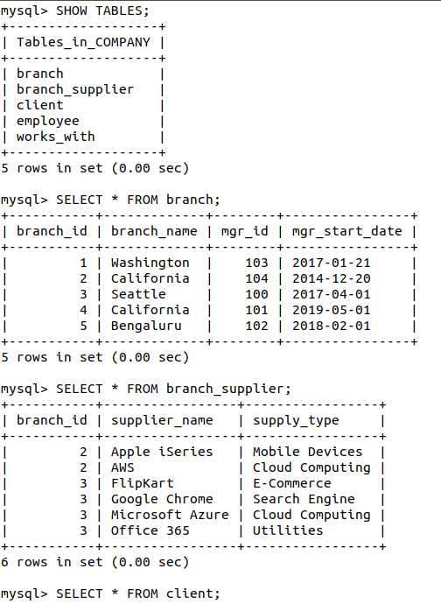

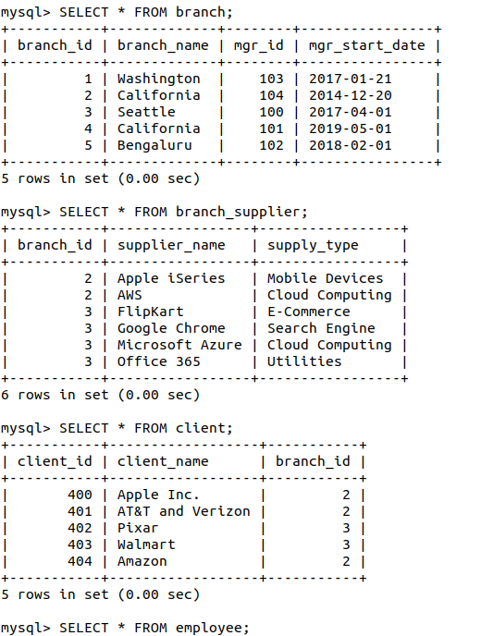

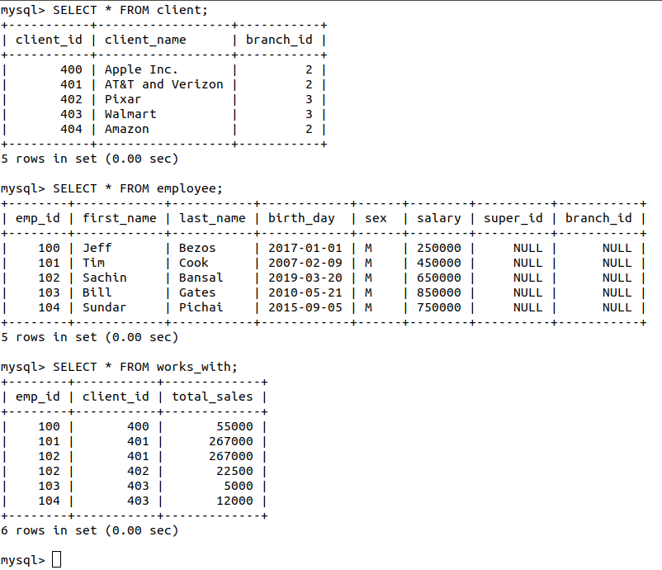

**(b) STUDENT database**

**SQL Queries :-**

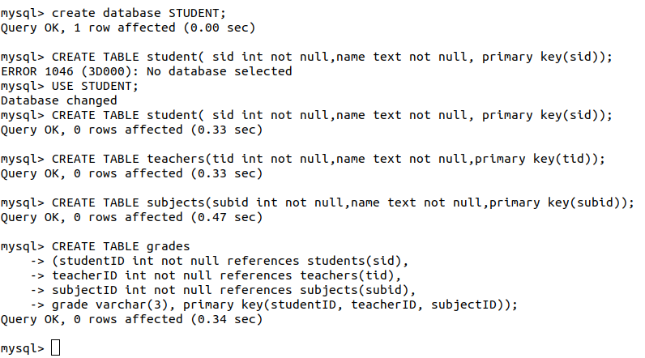

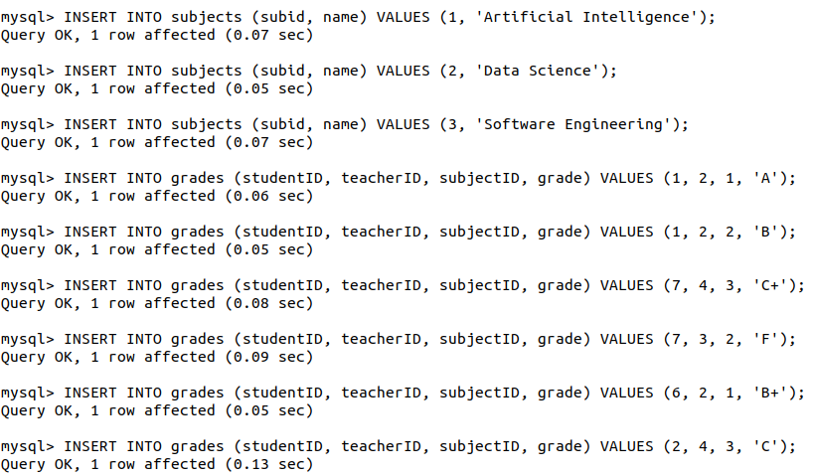

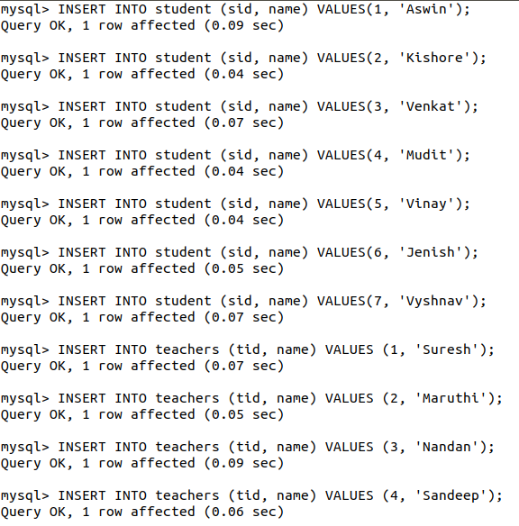

Result: I have successfully created company database and student database and also successfully inserted the values in both database.

**Question 6**: Illustrate the use of SELECT statement

**Aim:** To understand the uses of select statement in various cases

**SQL Queries :-**

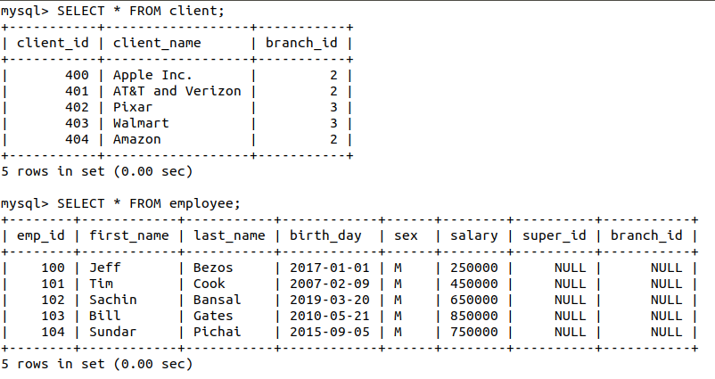

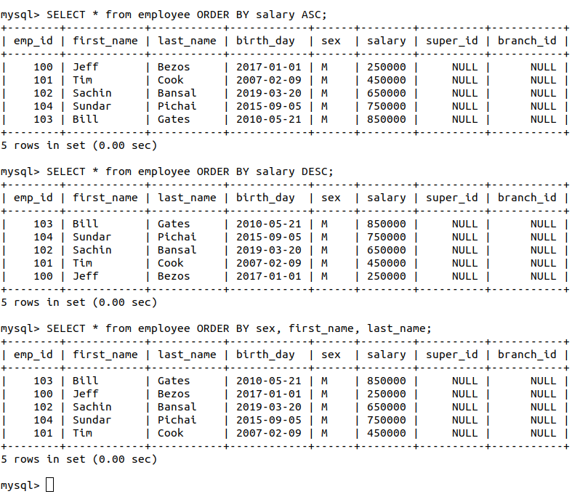

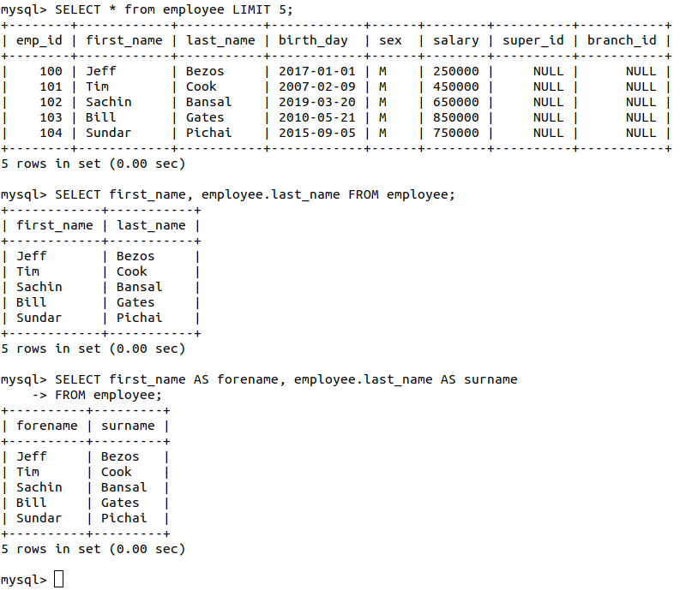

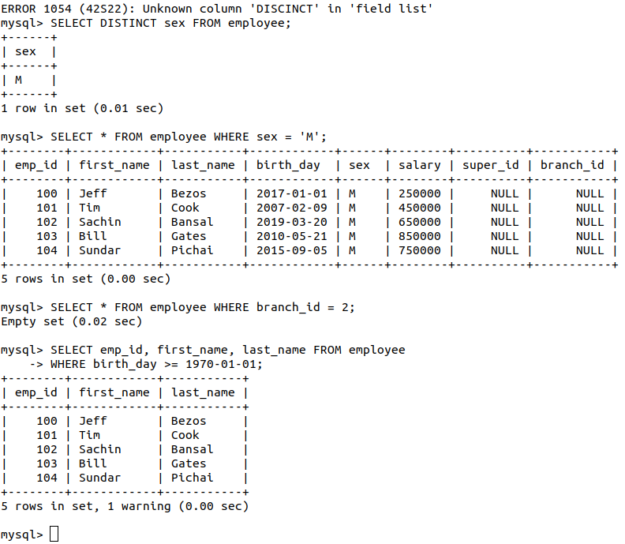

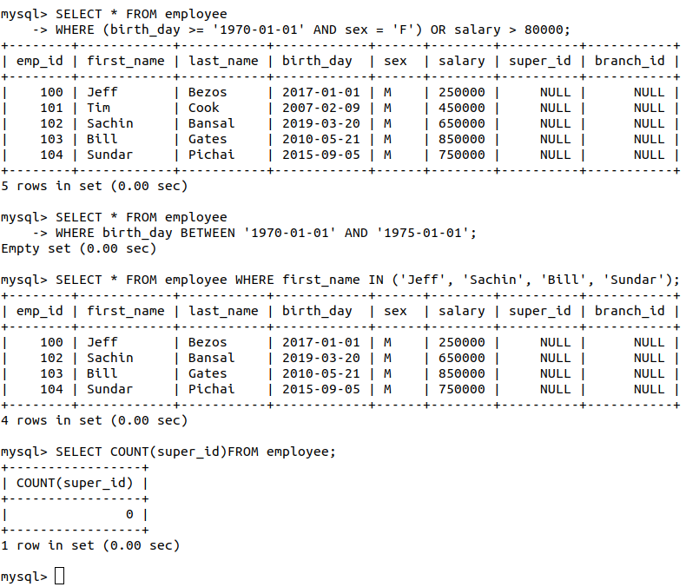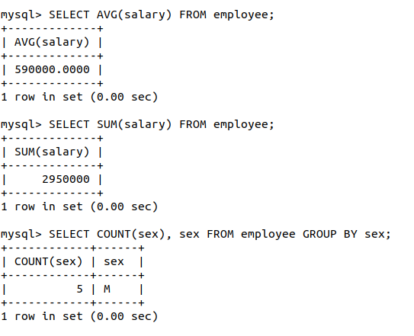

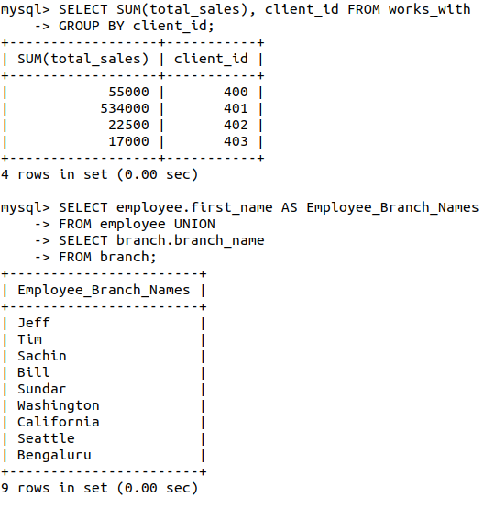

**SQL Queries :-**

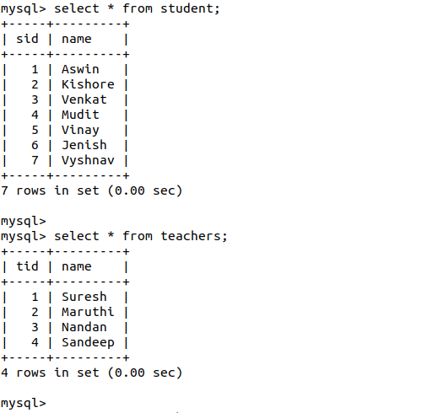

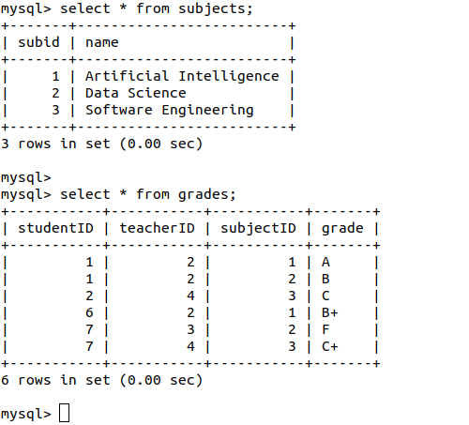

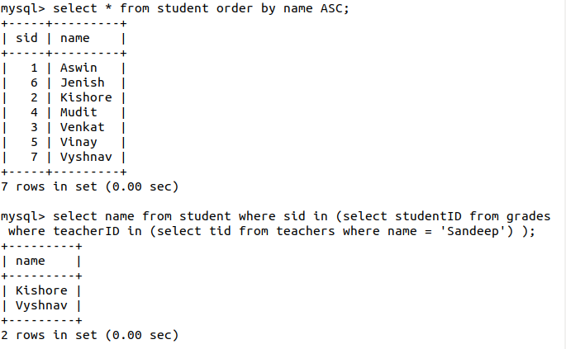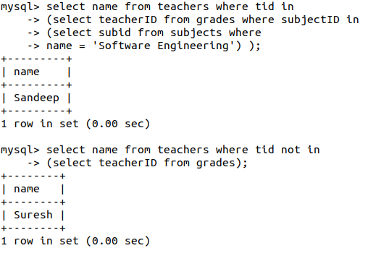

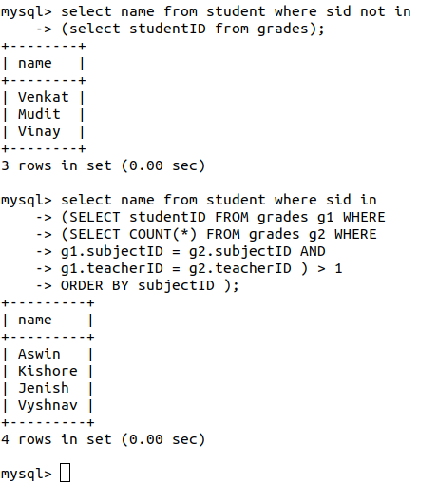

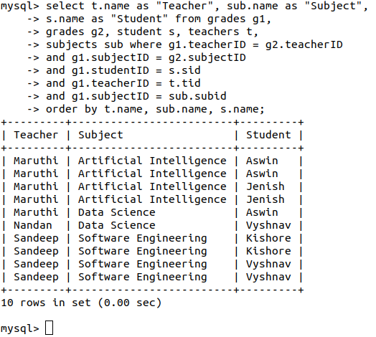

**Result:** I have successfully observed and executed the various types of use of select statement.

**Question 7 :** Conditional retrieval - WHERE clause.

**Aim:** To observe the use in where clause in various process.

Consider the following table :-

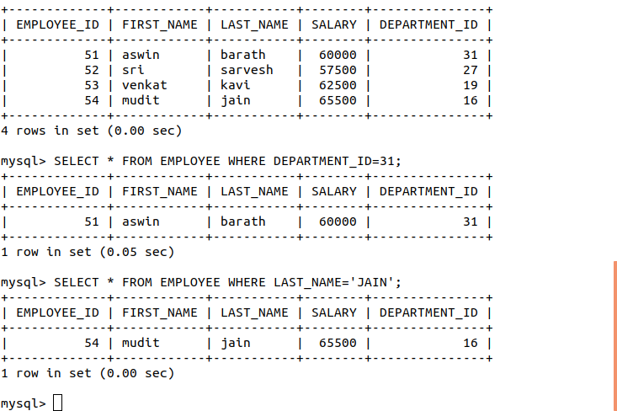

**SQL Queries :-**



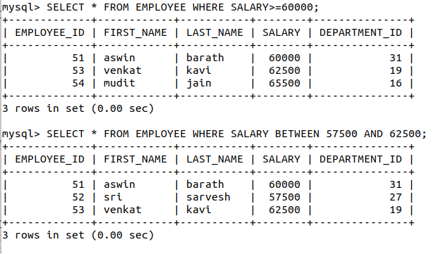

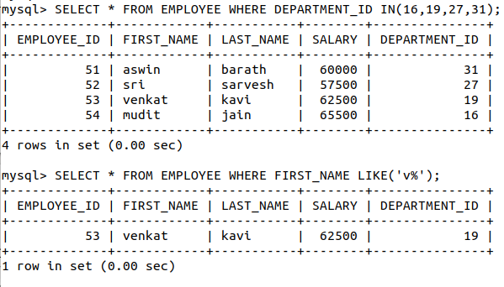

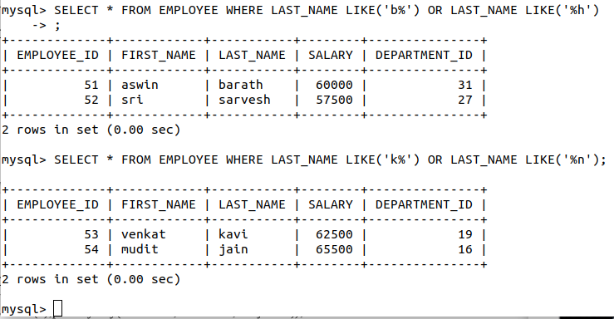

**Result:** Various uses of where clause is observed carefully and executed successfully.

**Question 8**: Query sorted - ORDER BY clause

**Aim:** To know about order by clause and display the result of using

order by clause.

Consider the following table :-



**SQL Queries :-**

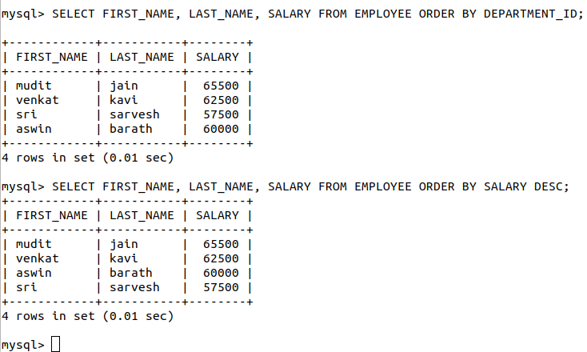

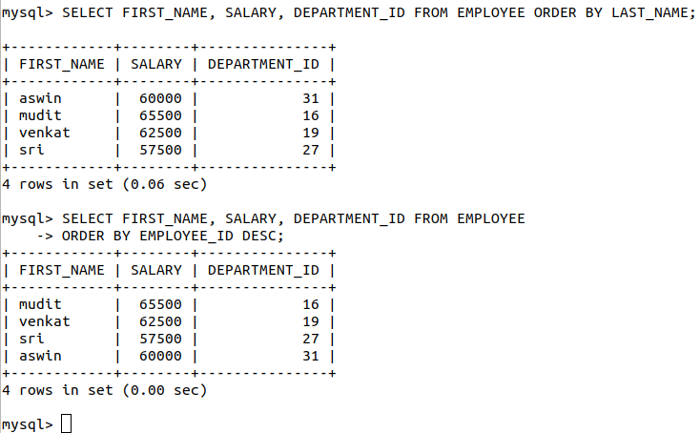

**Result:** I have used the both order by clause and got the idea how it is working and also successfully attach the files.

**Question 9(a)**: UNION, INTERSECTION and MINUS operations on tables

**Aim:** To get the full idea on UNION, INTERSECTION and MINUS on a table

Consider two tables named table1 and table2 with same attributes name and usn :-

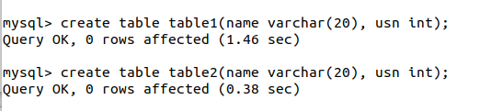

**SQL Queries :-**

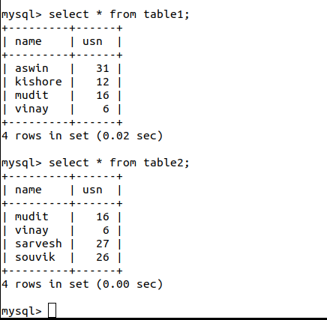

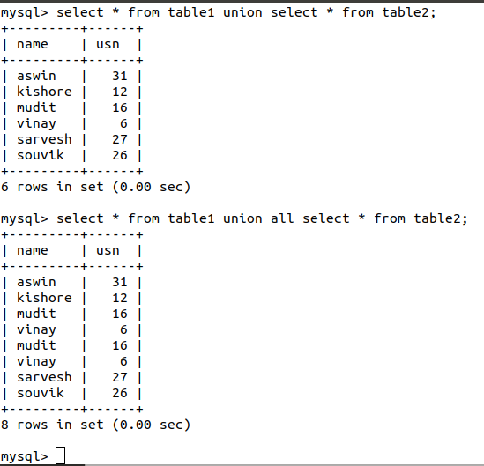

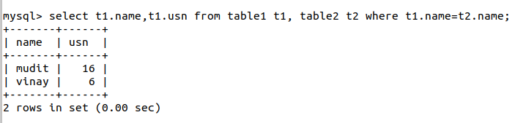

**Result:** I have successfully completed the union, intersection, minus operation on a table.

**Question 9(b)**: UPDATE, ALTER, DELETE, DROP operations on tables

**Aim**: To use update, alter, delete, drop statement in various ways in a table and observe the behavior of these command.

Consider the following table :-

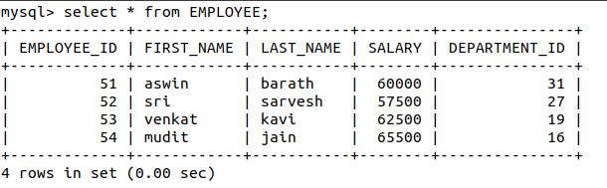

**SQL Queries :-**

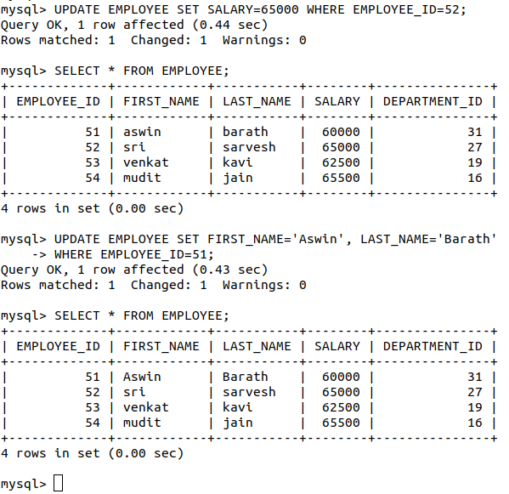

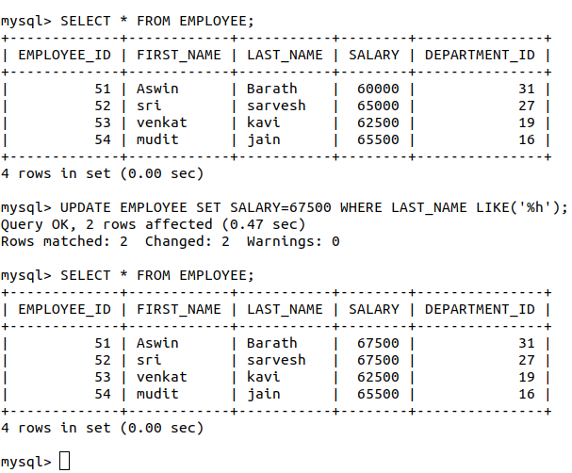

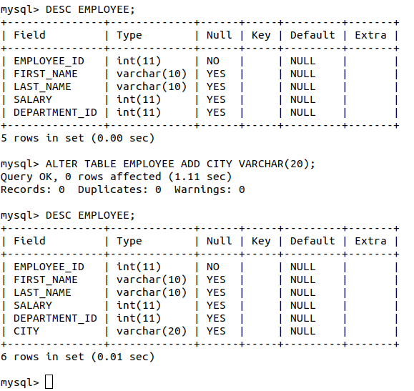

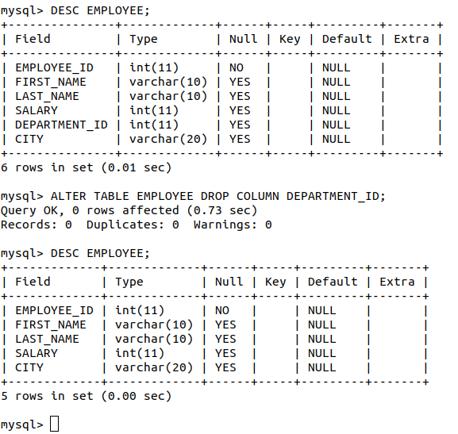

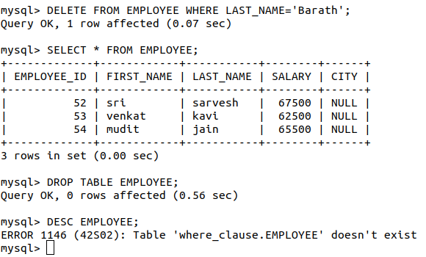

**Result**: I have successfully executed UPDATE, ALTER, DELETE, DROP SQL commands.

**Question 10:** Query multiple tables using JOIN operation.

**Aim:** To use all join operation on two tables

Consider the following two tables for join operations :-

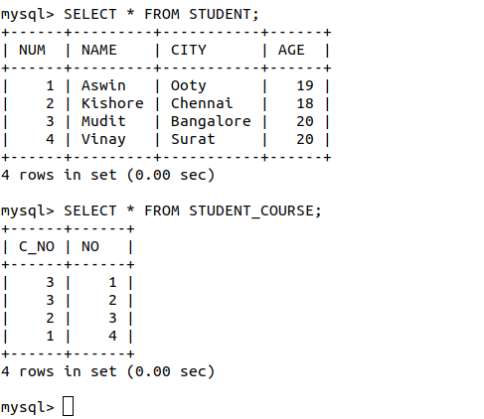

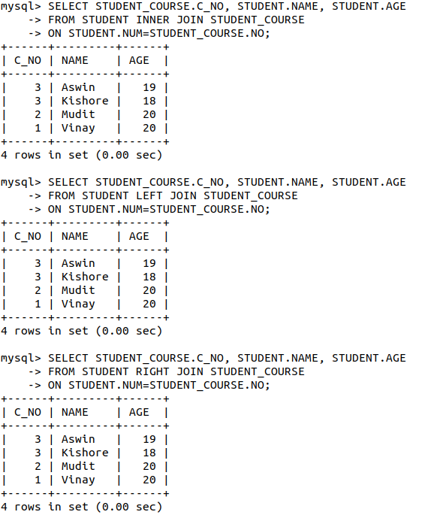

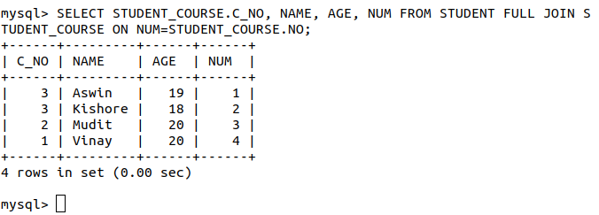

**Result**:I have successfully executed all types of join (Inner Join, Left Join, Right Join, Full Join) commands on two tables.

**Question 11:** Grouping the result of query - GROUP BY clause and HAVING clause

**Aim:** To use the group by clause and having clause. As we know also having clause is optional.

Consider the following table:

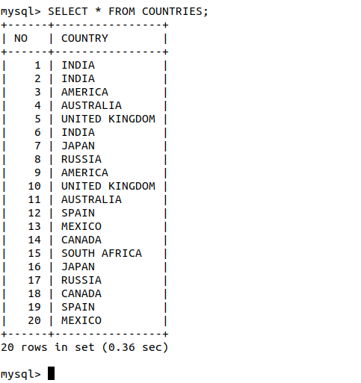

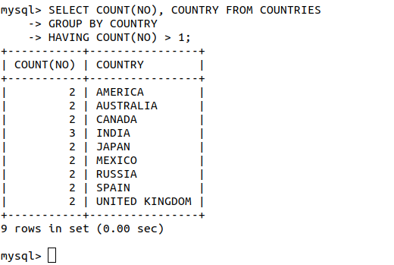

**Result:** I have successfully executed the “group by” and “having” clause commands.

**Question 12:** Query multiple tables using NATURAL and OUTER JOIN operation.

**Aim:** To see how the result is look like after using NATURAL and OUTER JOIN operation.

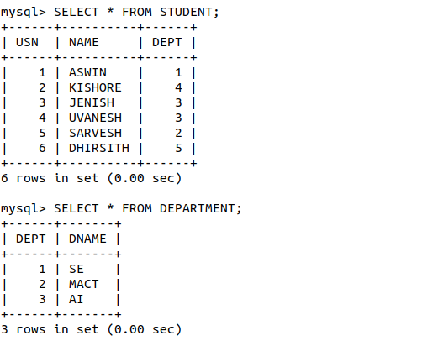Consider the following two tables:

**SQL Queries :-**

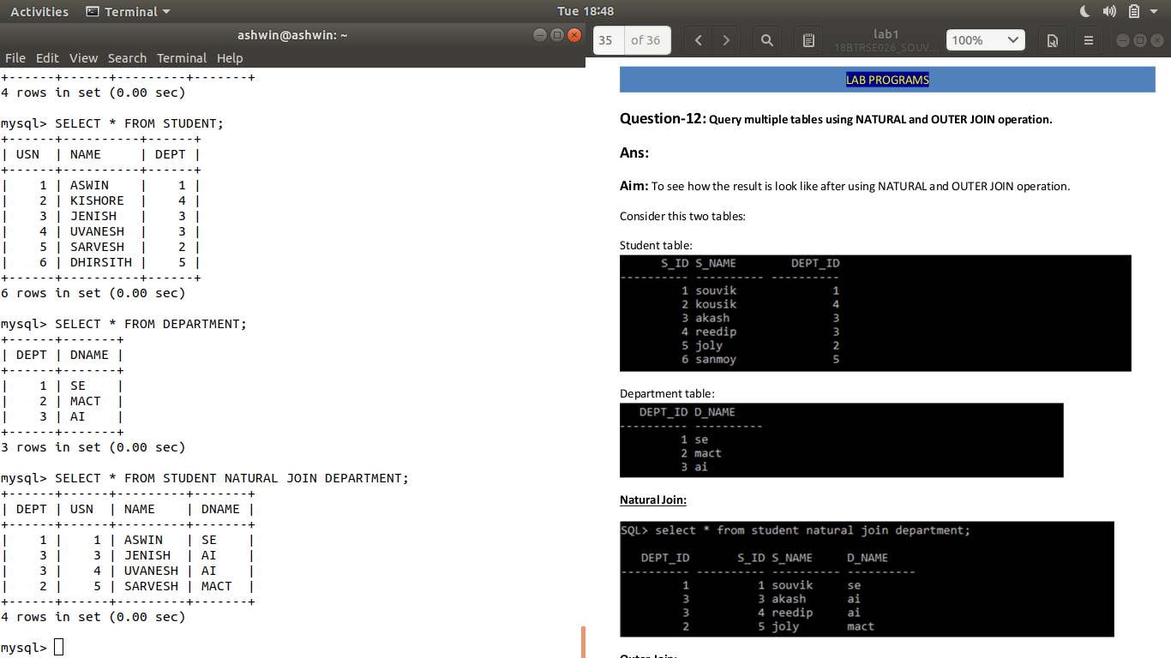

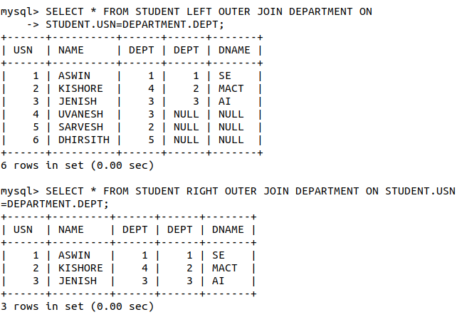

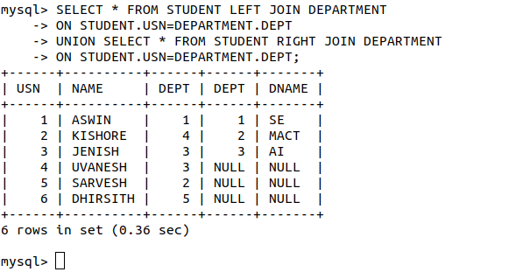We don’t have Full Join in MySQL, so I’ve emulated using Left and Right Join with the help of Union.

**Result:** I have successfully executed the NATURAL JOIN, OUTER JOIN (left outer join, right outer join, full outer join[“Using left and right join”]) operations on two tables STUDENT table and DEPARTMENT table.